Testing using POSTMAN
- Valid Login
Input- Correct email and password
Output – 200 OK and JWT returned.
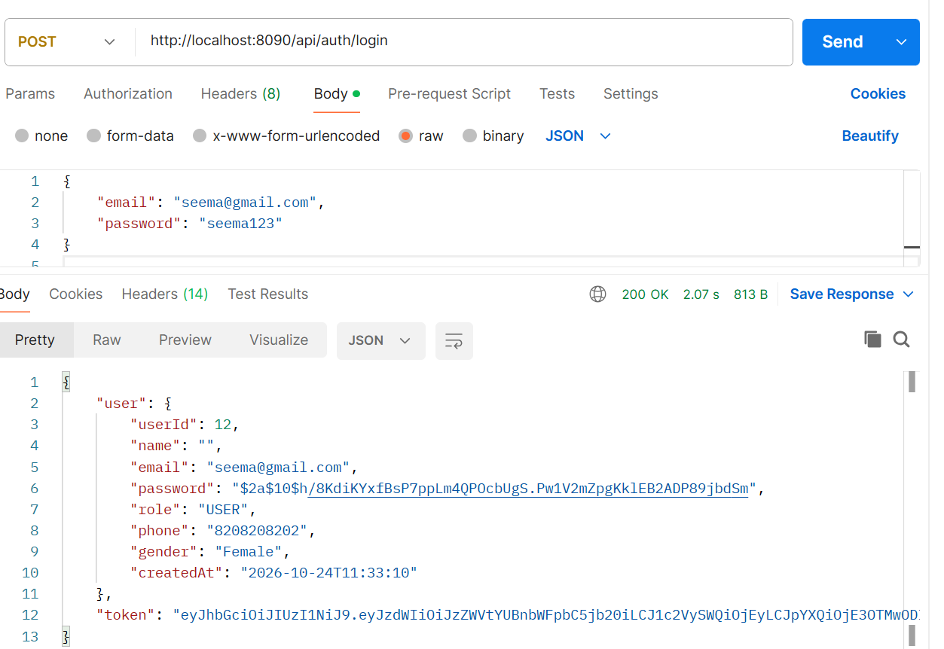
- Invalid password –
Input – Correct email /wrong password
Output- 401 Unauthorized.
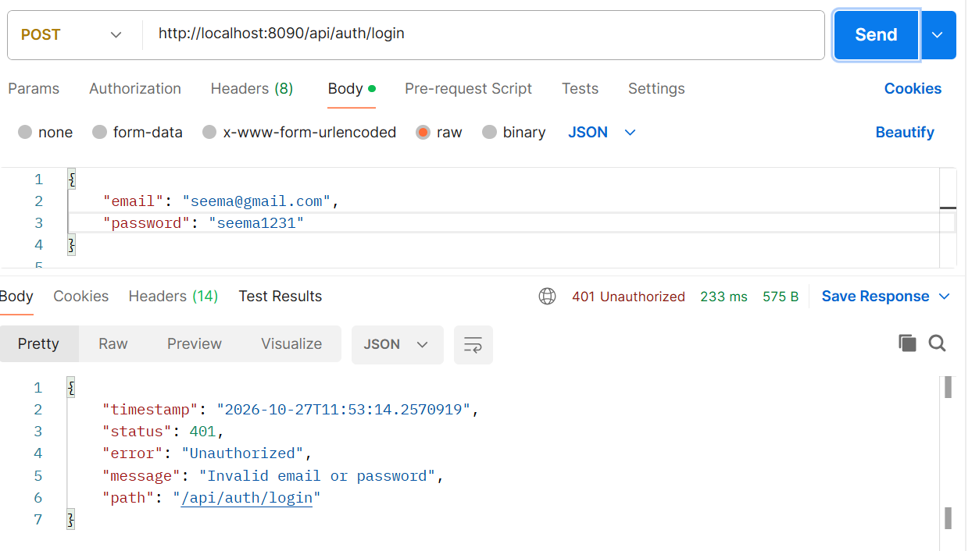

- User does not exist
Input – Unknown email
Output – 401 Unauthorized
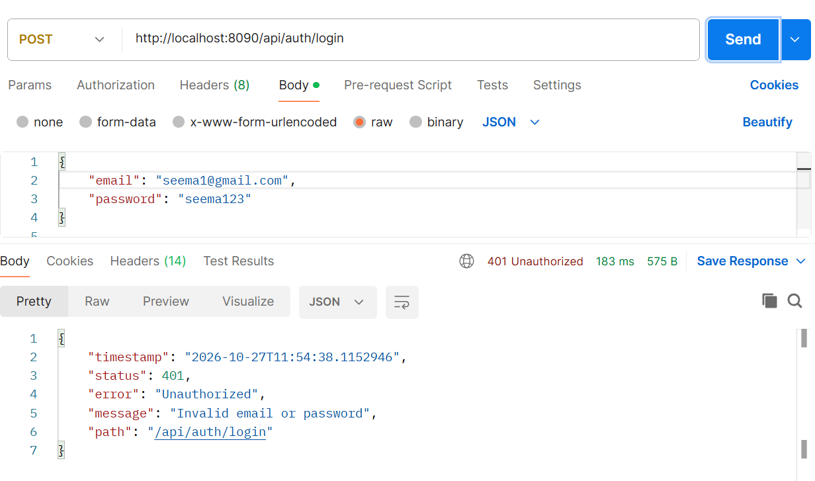

- Access Secured API Without Token
No Authorization header

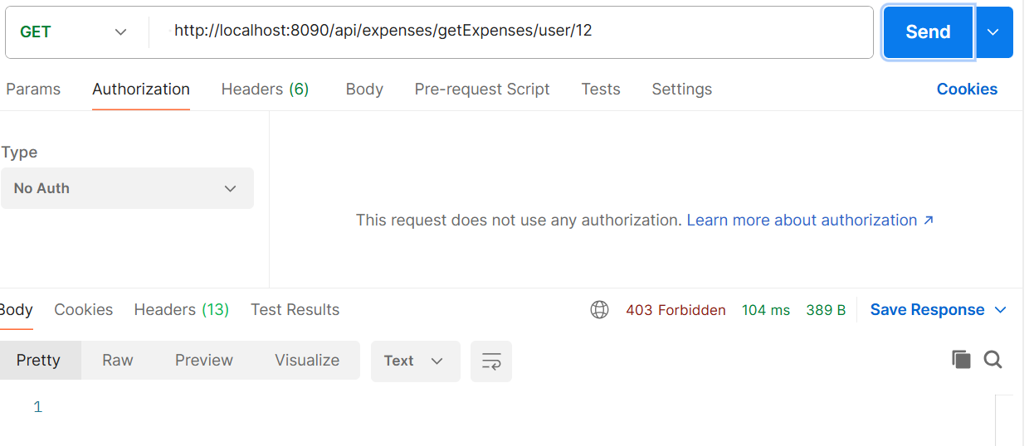

Accessed secured APIs without JWT actually request is reaching to spring security but no JWT authentication is happening, and Spring Security is denying access before controller executes. Hence, it shows 403 Forbidden (which is actually expected to be 401 unauthorized). This can be taken care in future enhancement.

- Invalid JWT
Input – Invalid token entered
Output- 401 – Invalid Token
JWTException thrown
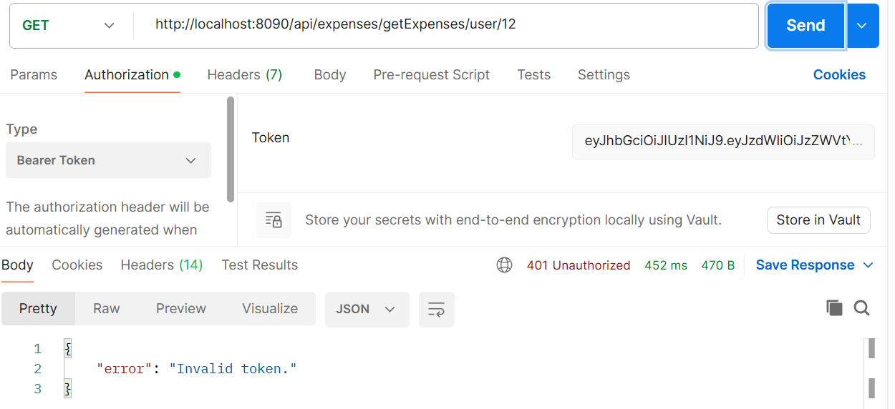

- Expired JWT

Modified JWT expiration time to 5 mins for testing and after 5 mins tested for an API.
Output- 401 Token expired
ExpiredJwtException thrown.
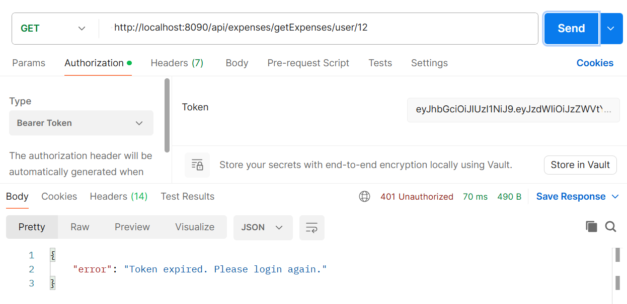

- Access another User's Data
Input – Token is authenticated for UserId 12 but tried to access data for another user (UserId 10).
Output-403 Forbidden Access denied.
(Though token is valid for UserId 12 but it can’t access data with that token for another user (UserId 10))

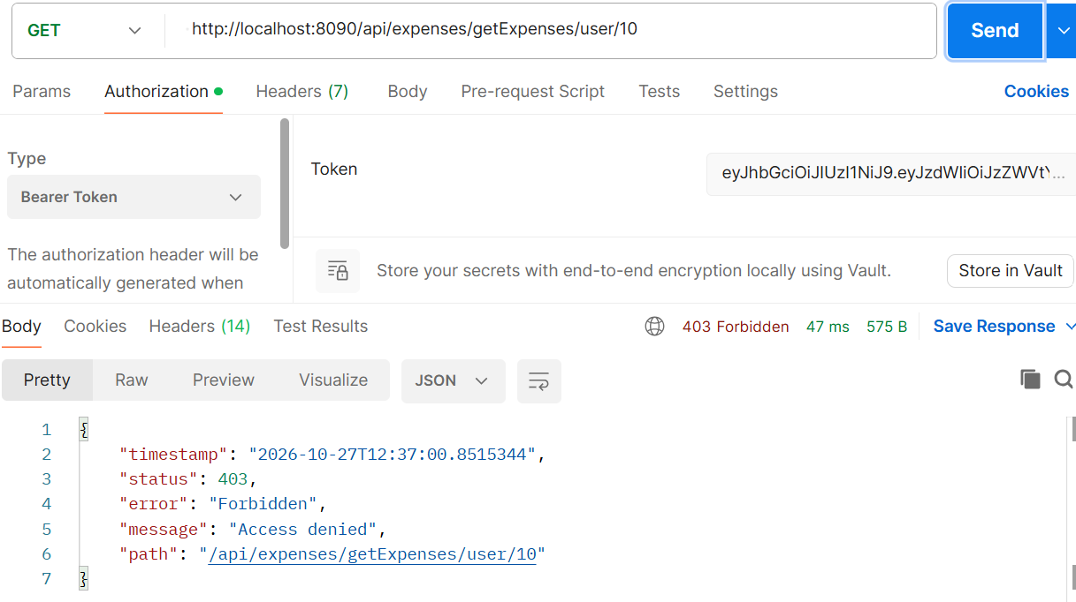

- Access Admin Endpoint As USER
User has no permission to delete expense as its role is USER. Only Admin user is allowed to delete expense.
Output- 403 Forbidden
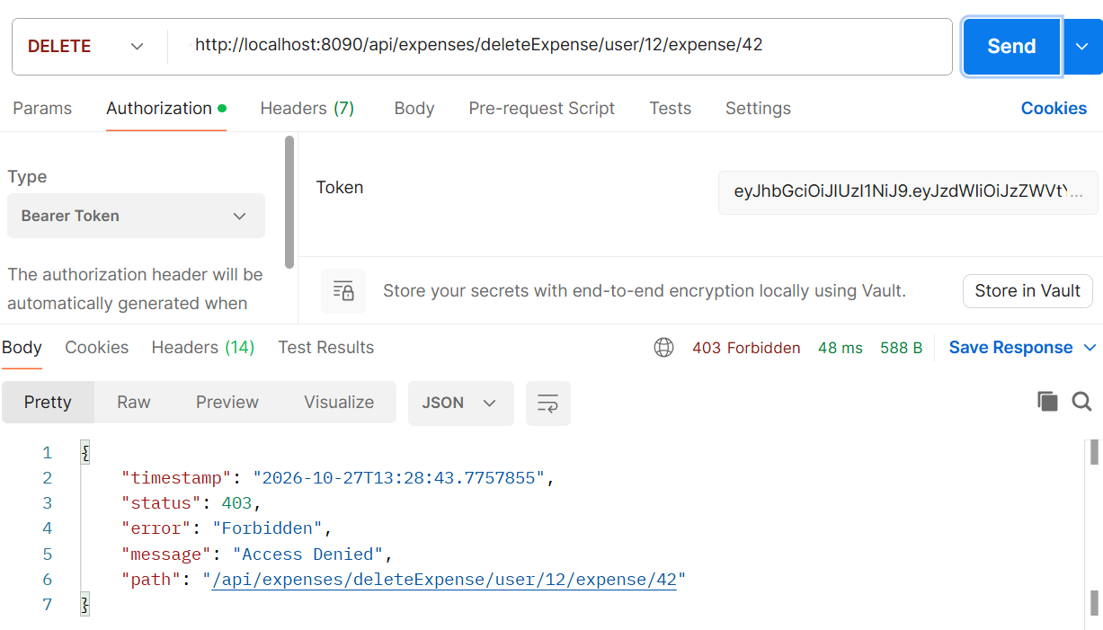

- Access USER Endpoint with USER (say add expense)
Output- 200 Ok (Added expense successfully)

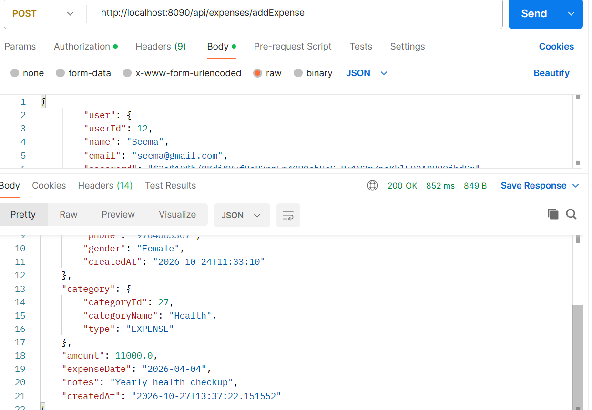

Testing through UI
- User login with correct credentials
Output: Dashboard opens and token stored in local Storage.

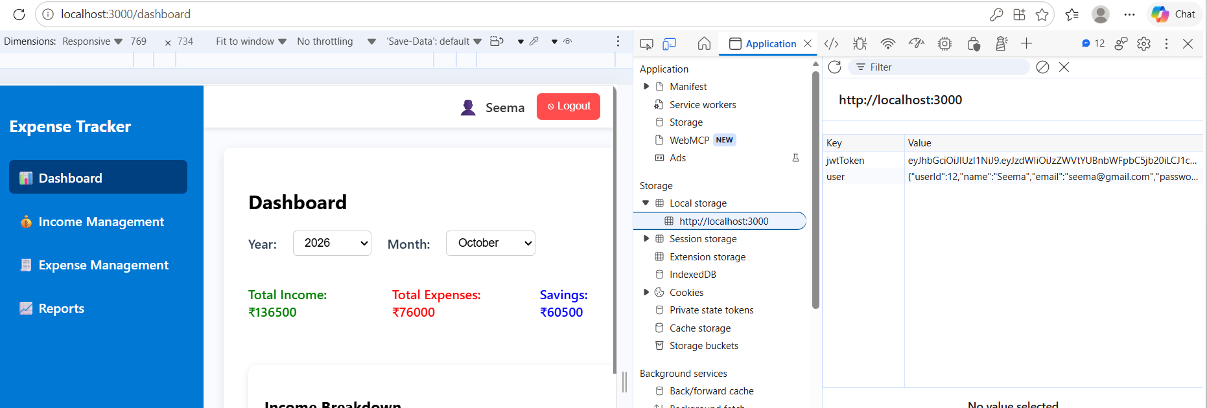

- Expired Token
After login wait for 10 mins and then clicked on Income Management screen. It redirected to login screen saying Token expired.

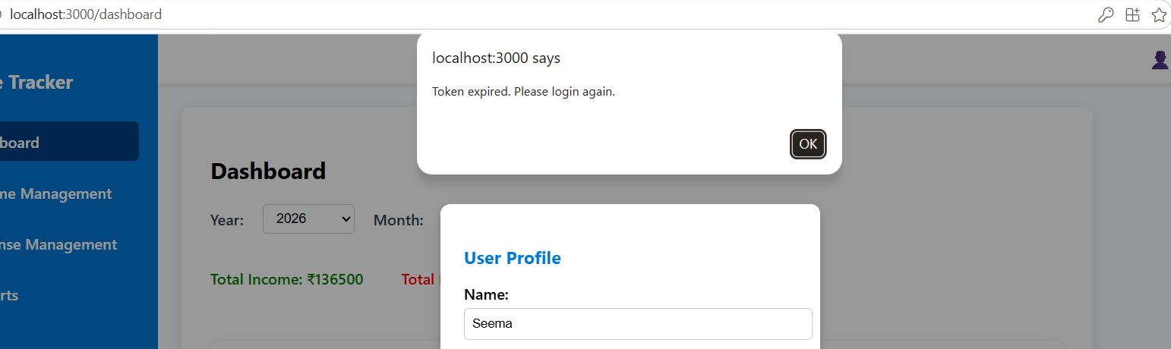

Received error on backend as:
Expired JWT token received for URI /api/user/update/12

- Invalid email/password entered
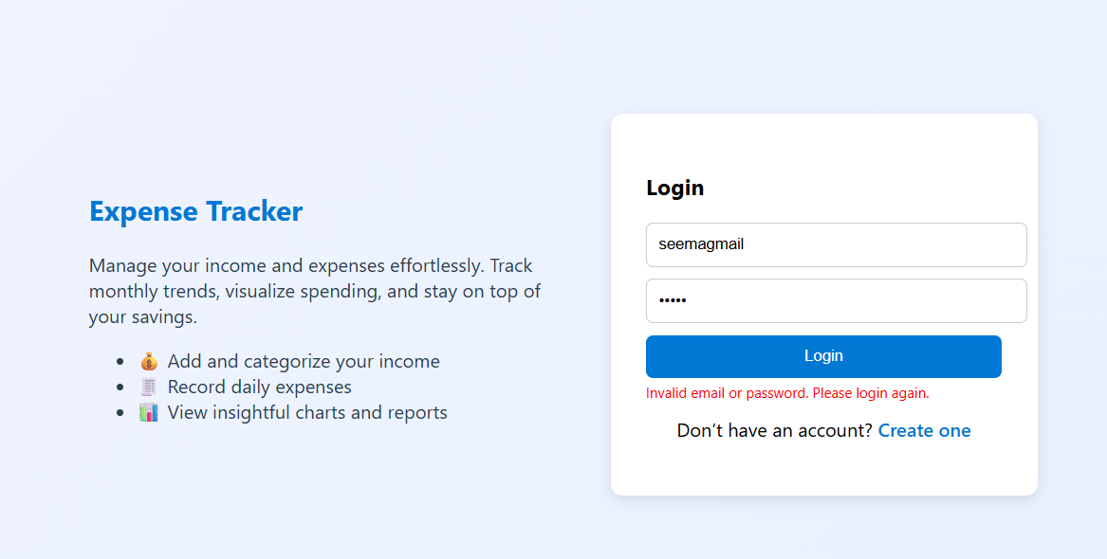
Received error on backend:
Invalid email or password: Bad credentials

